A step by step guide to create and run the project.

Step 1. Go to File – Select New and click on Project

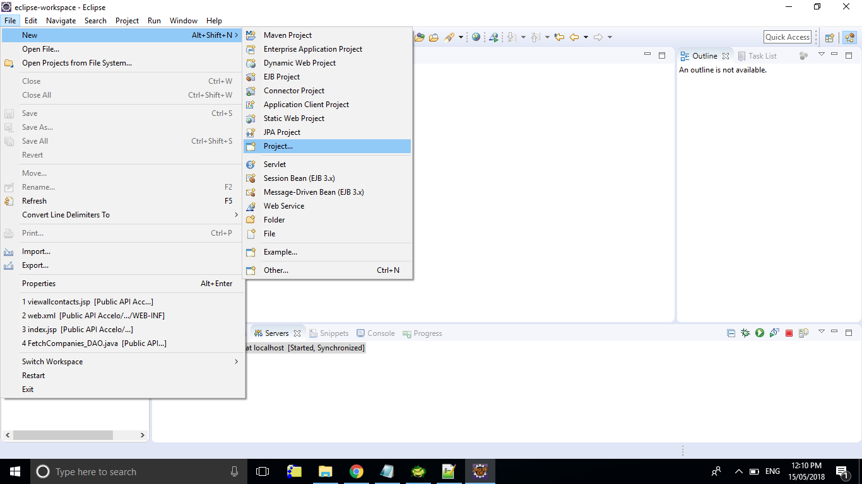

Step 2 – Select the dynamic web project as follows:

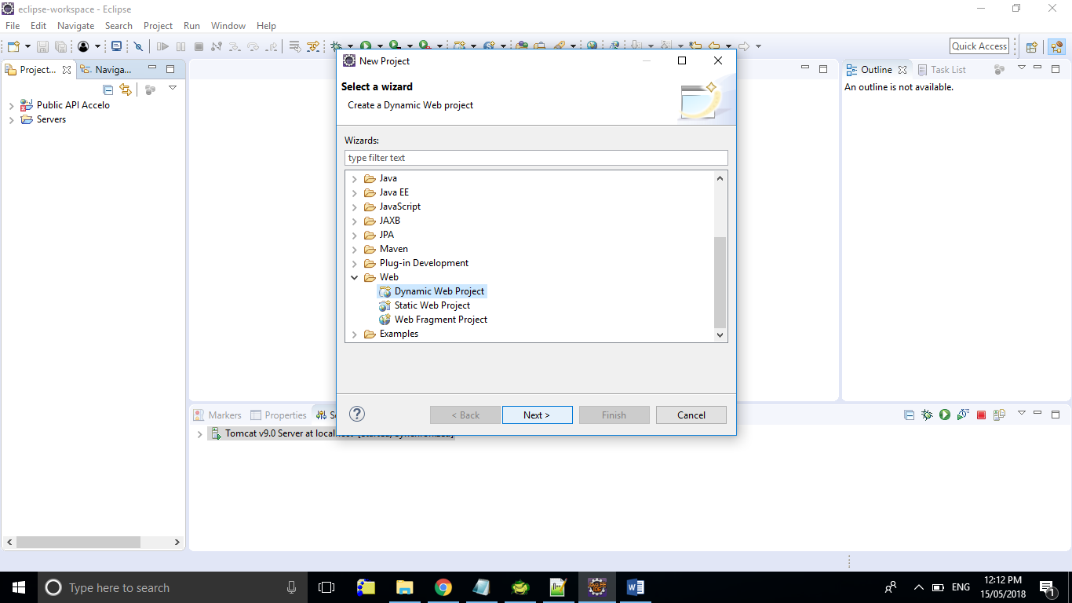

Step 3: Create the project with the details as follows:

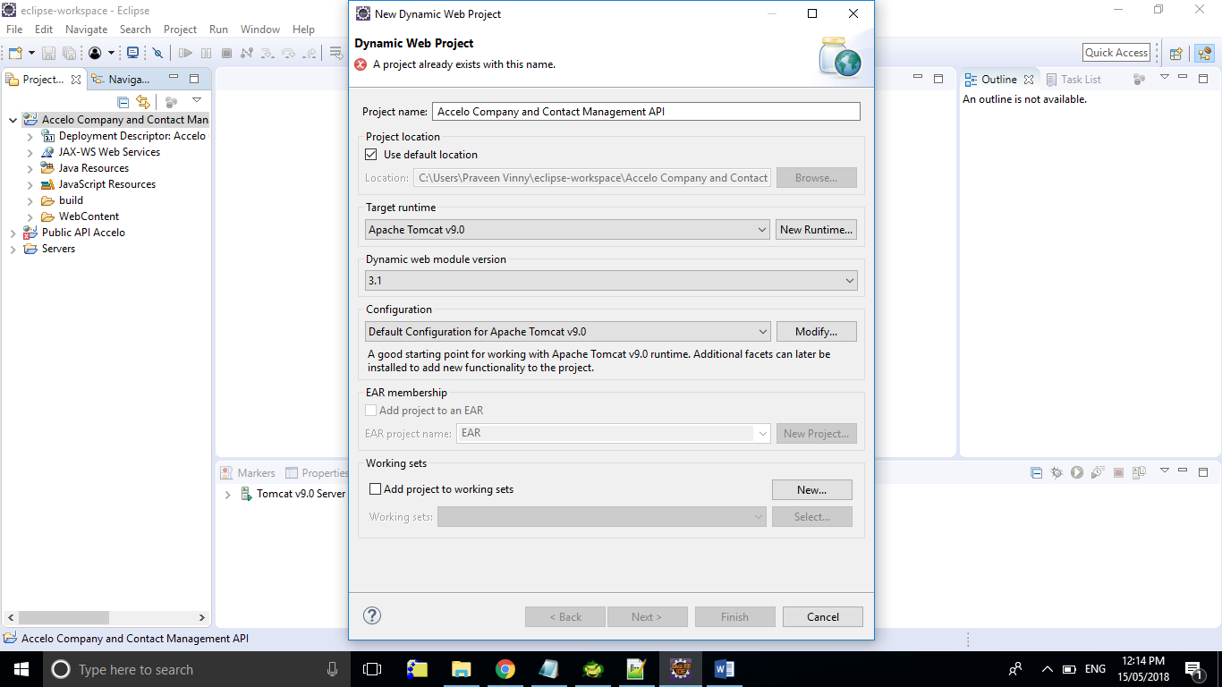

Step 4: Copy all the jsp files in the folder WebContent to the WebContent folder in the new project created.

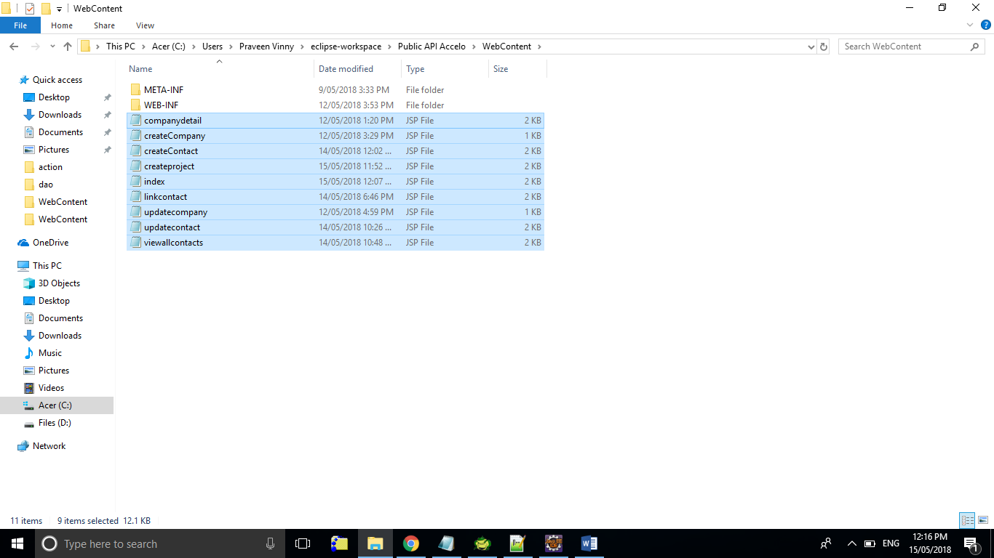 to 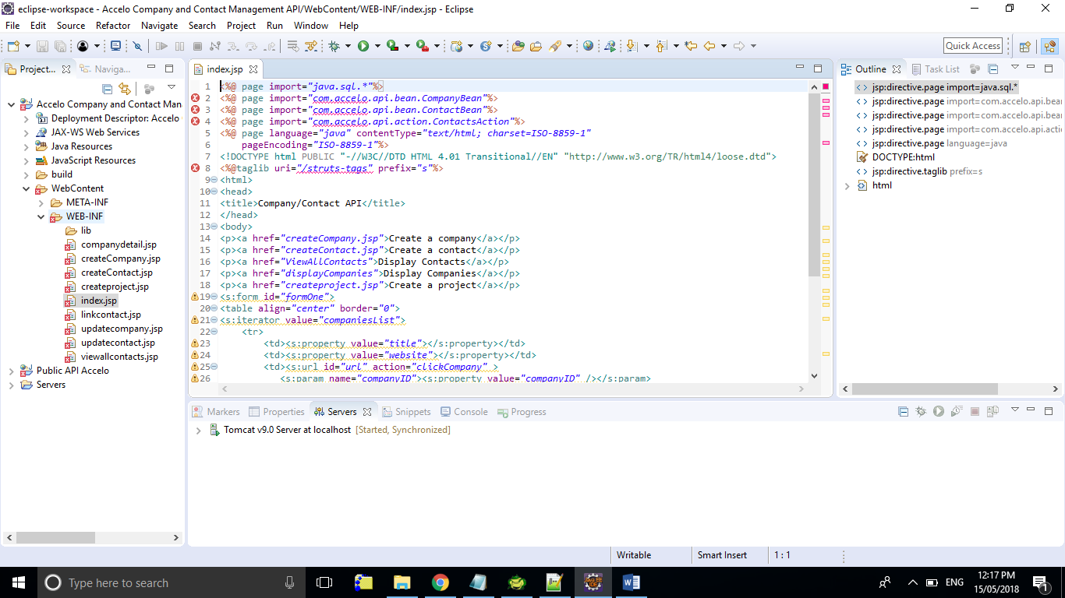

Step 5: Create packages with the same names as follows:

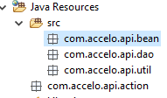

Step 6: Copy struts.xml to into the src folder as follows:

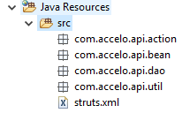

Step 7: Copy all the classes to their respective packages.

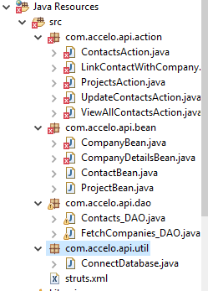

Step 8: Copy the struts libraries to the folder WEB-INF/lib as follows:

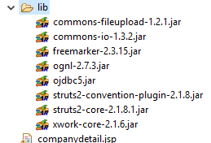

from

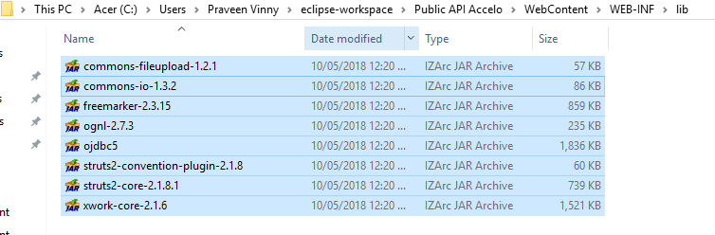

You can find these files in the same directory of the project uploaded. Please find the image above for your reference.

Step 9: Now select the server as the Tomcat server.

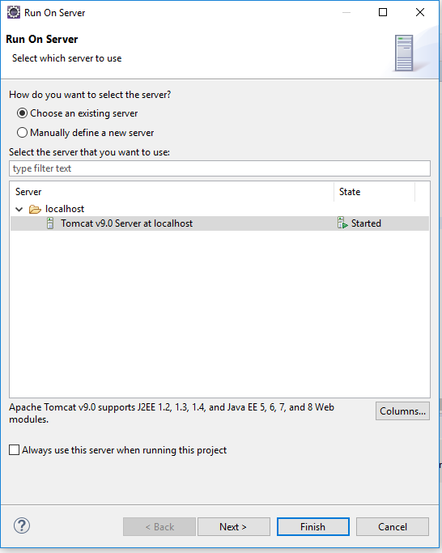

Step 10: Restart the server if its already running.

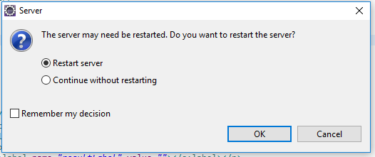

You will see messages appearing in red in the console. These are the server logs when we are running the struts based programs. So we don’t have to be bothered about that.

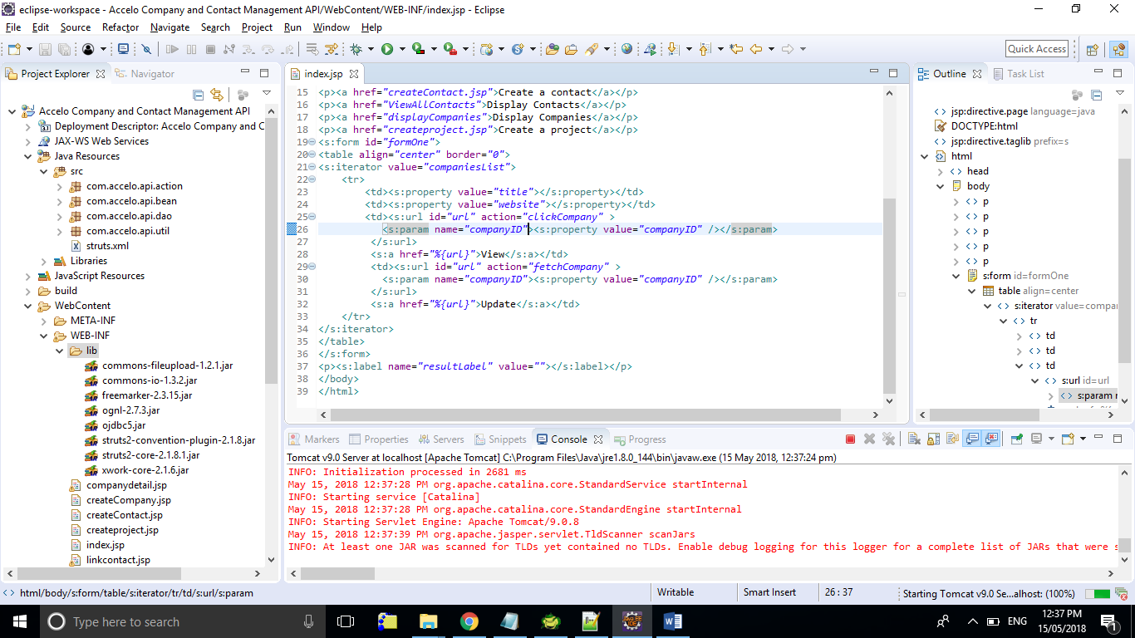

Step 11: If a server doesn’t exist, define a new server as follows:

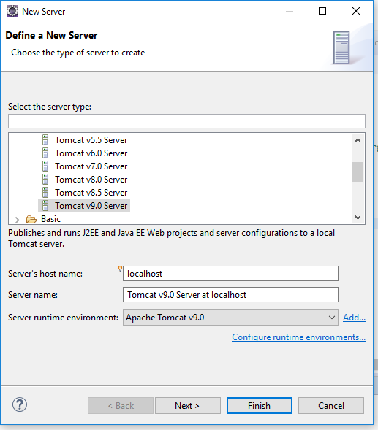

Step 12: Right click the project and click on run as -> run on server.

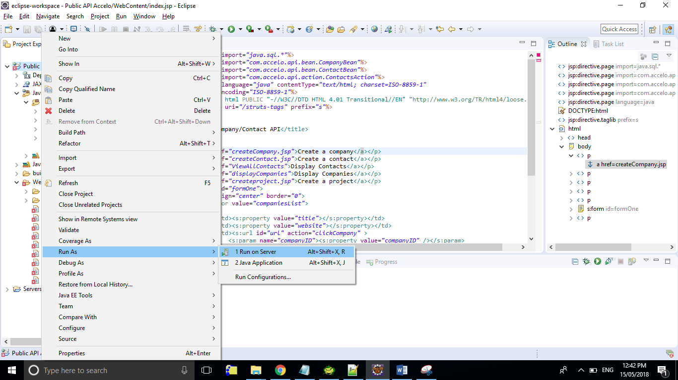

Step 13: If you get a message as follows, reconfigure the server with a different port number.

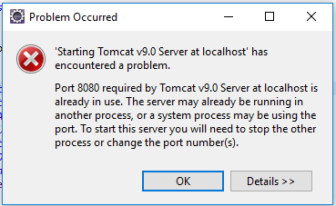

Step 14: Enter the port details as follows after double clicking on the server:

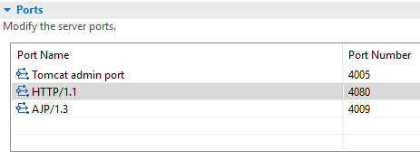

Step 15: Click on Run again.